Screenshots showing program in action.

State of an interesting portion of one of the directories in question.

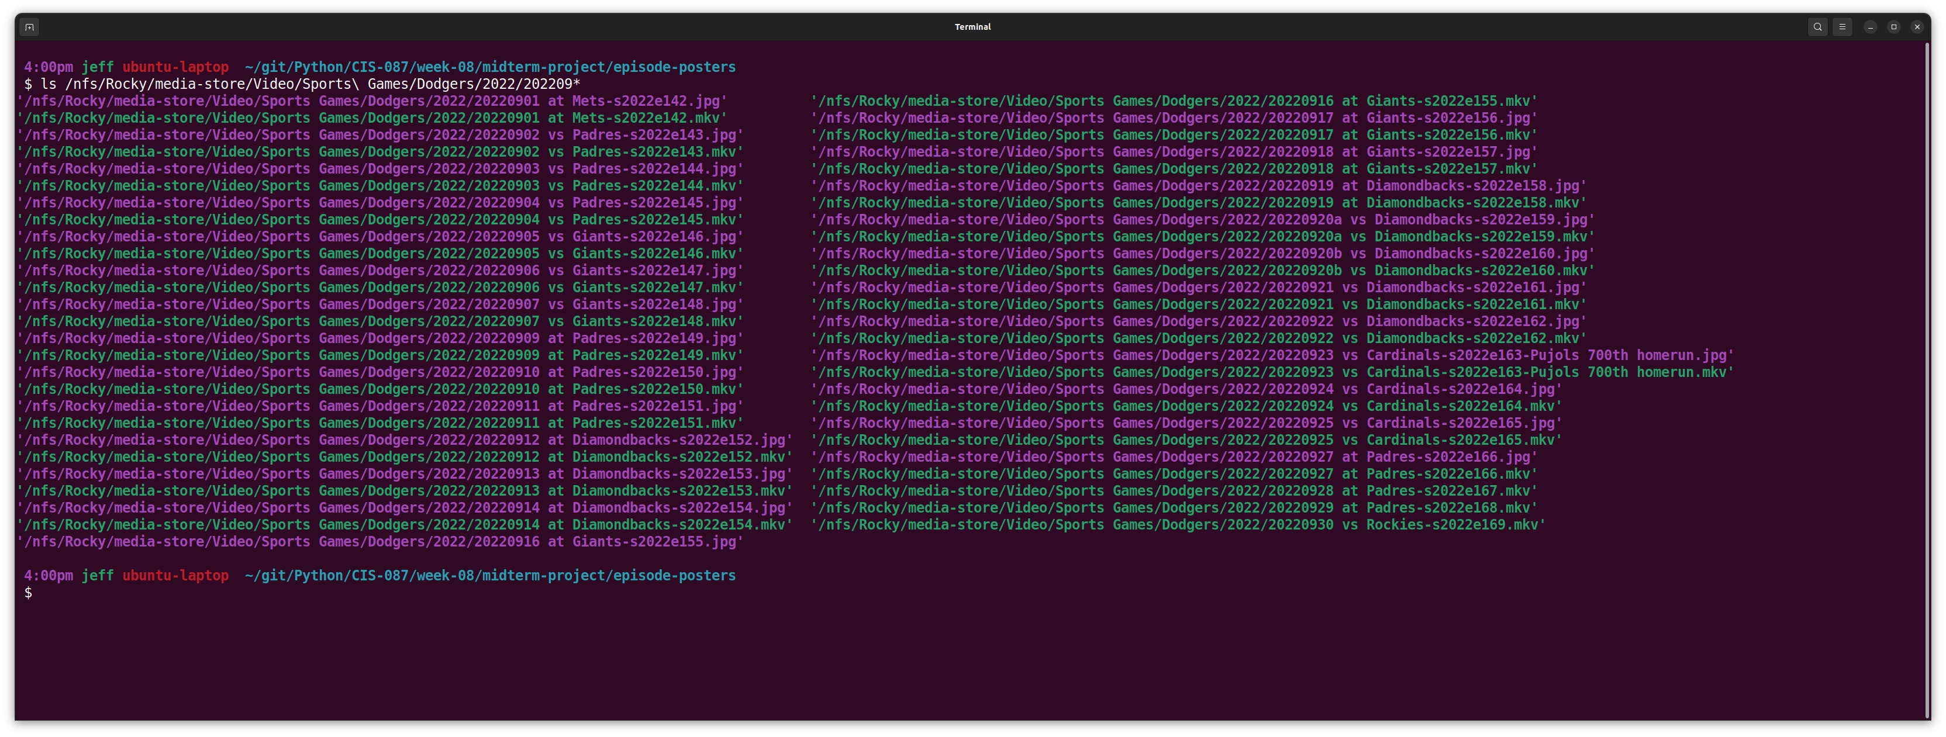

The last 13 files of the directory:

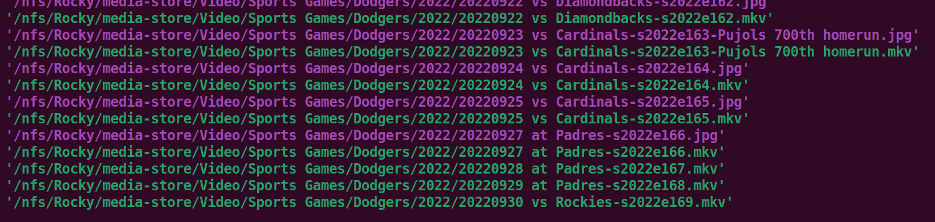

The above directory listing indicates that some of the *.mkv files have associated *.jpg files (with the same name). However the last 3 games do not. These are the games from 20220928, 20220929, and 20220930. When complete, these games should have associated *.jpg files.

The next page includes a screenshot of the program executing in a bash shell. You will see the “python episode_posters.py” execution command. As the program runs, it displays the newly created *.jpg files. Once the program concludes, you see the bash shell display a new prompt as expected.

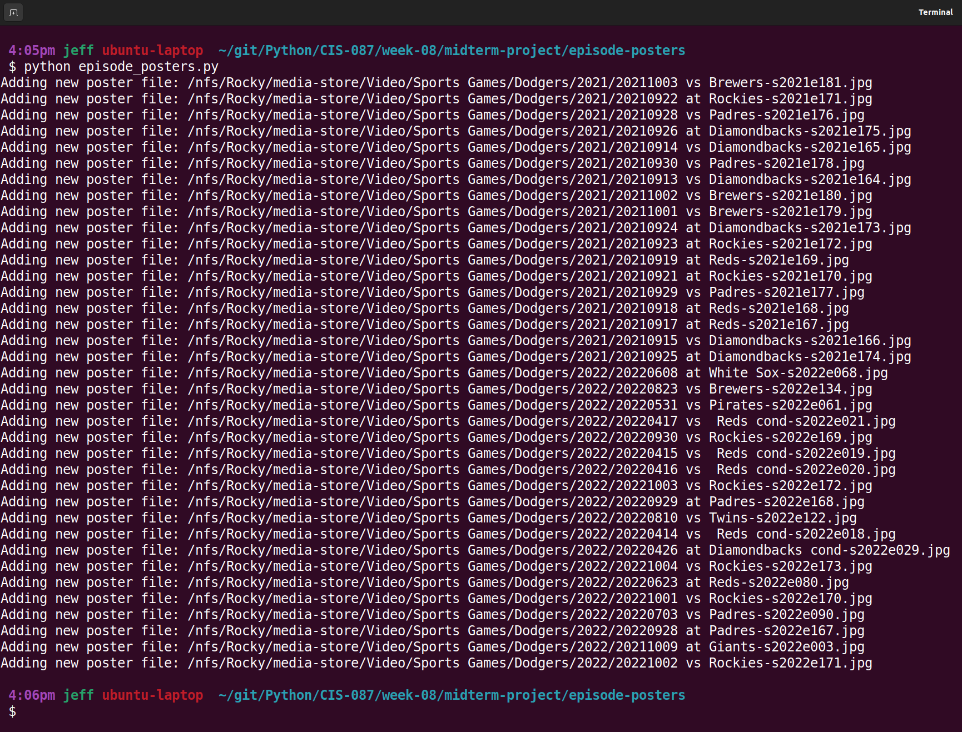

If we look closely, we see that files “20220928 at Padres-s2022e167.jpg”, “20220929 at Padres-s2022e168.jpg”, and “20220930 vs Rockies-s2022e169.jpg” have been logged as added to directory structure. The next 3 screenshots highlight each of the three files as evidence. The program does not sort the file names, so they are processed (and thus displayed) in random order.

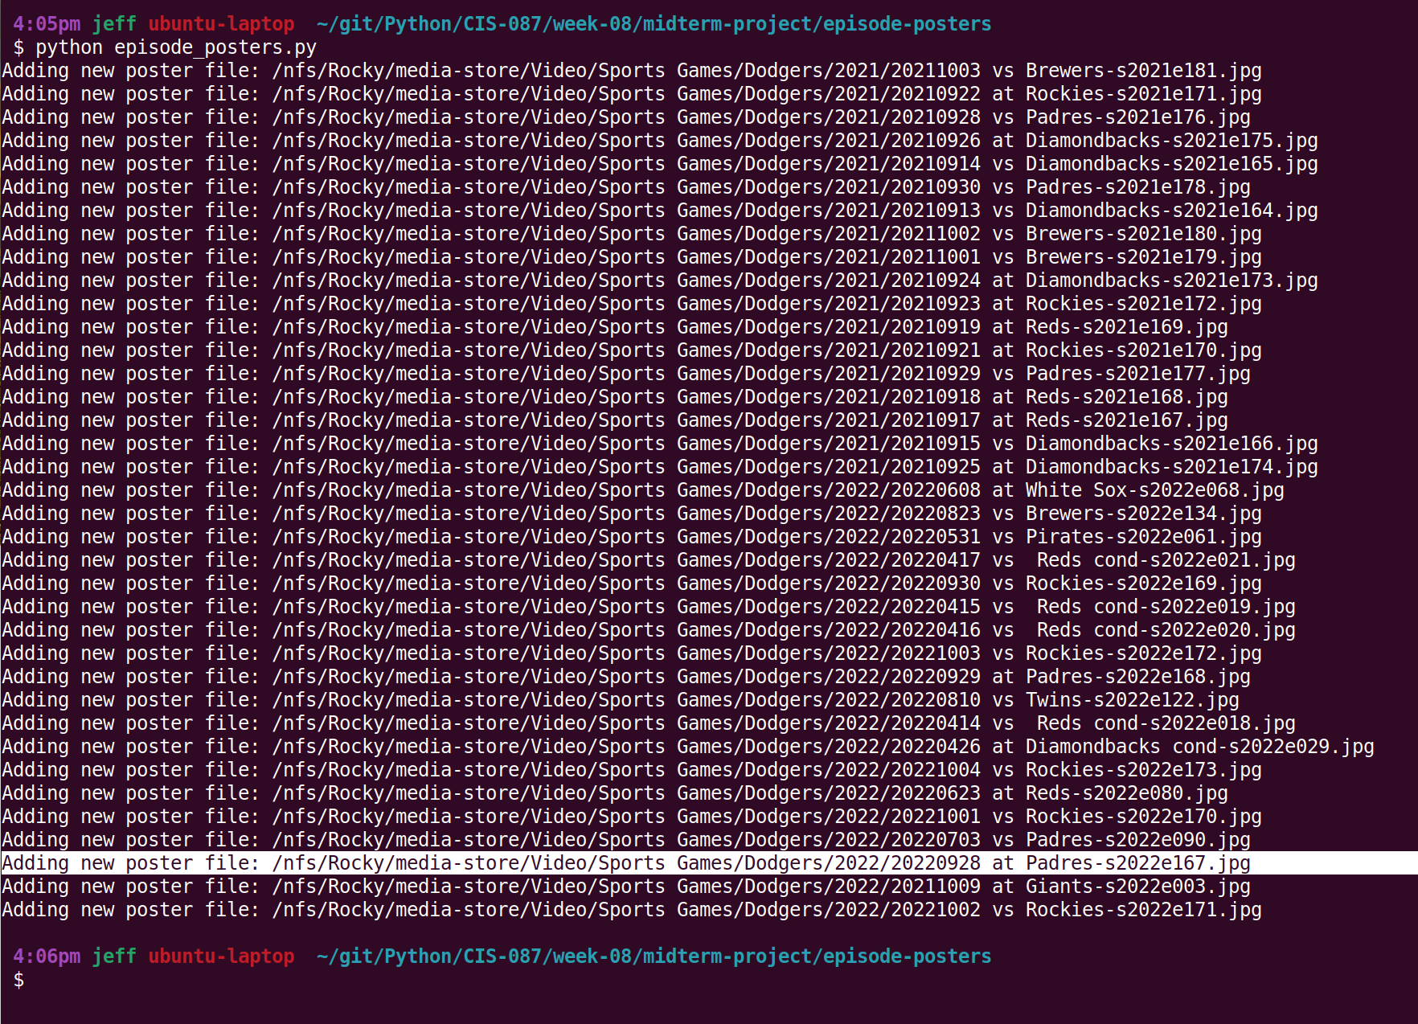

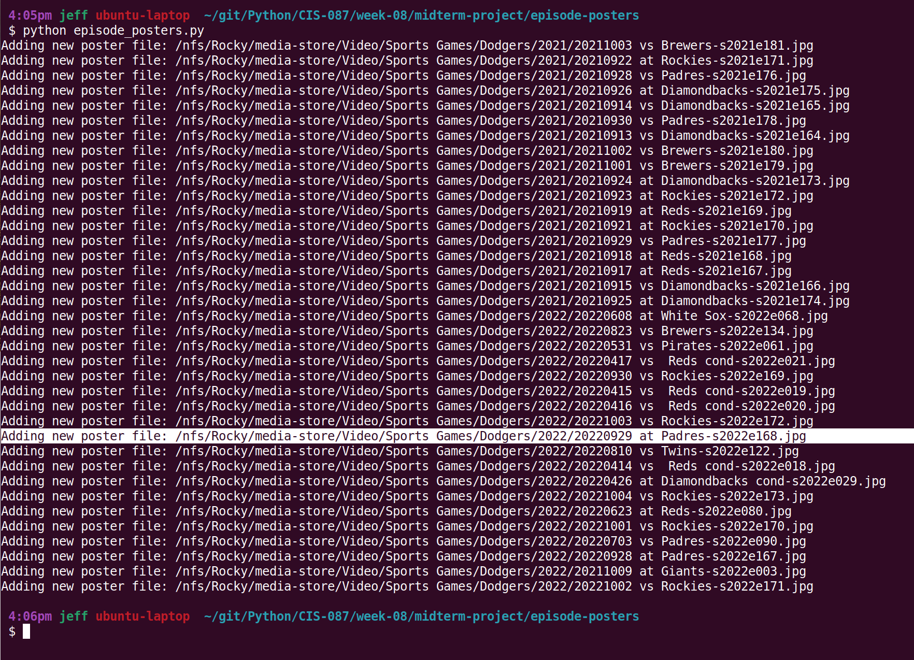

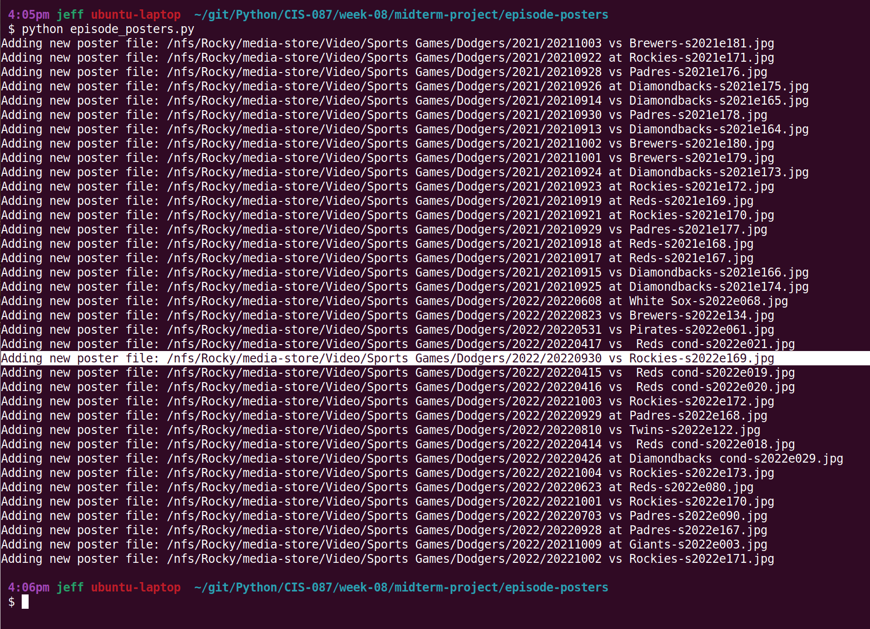

Here is the directory listing taken after the program is executed:

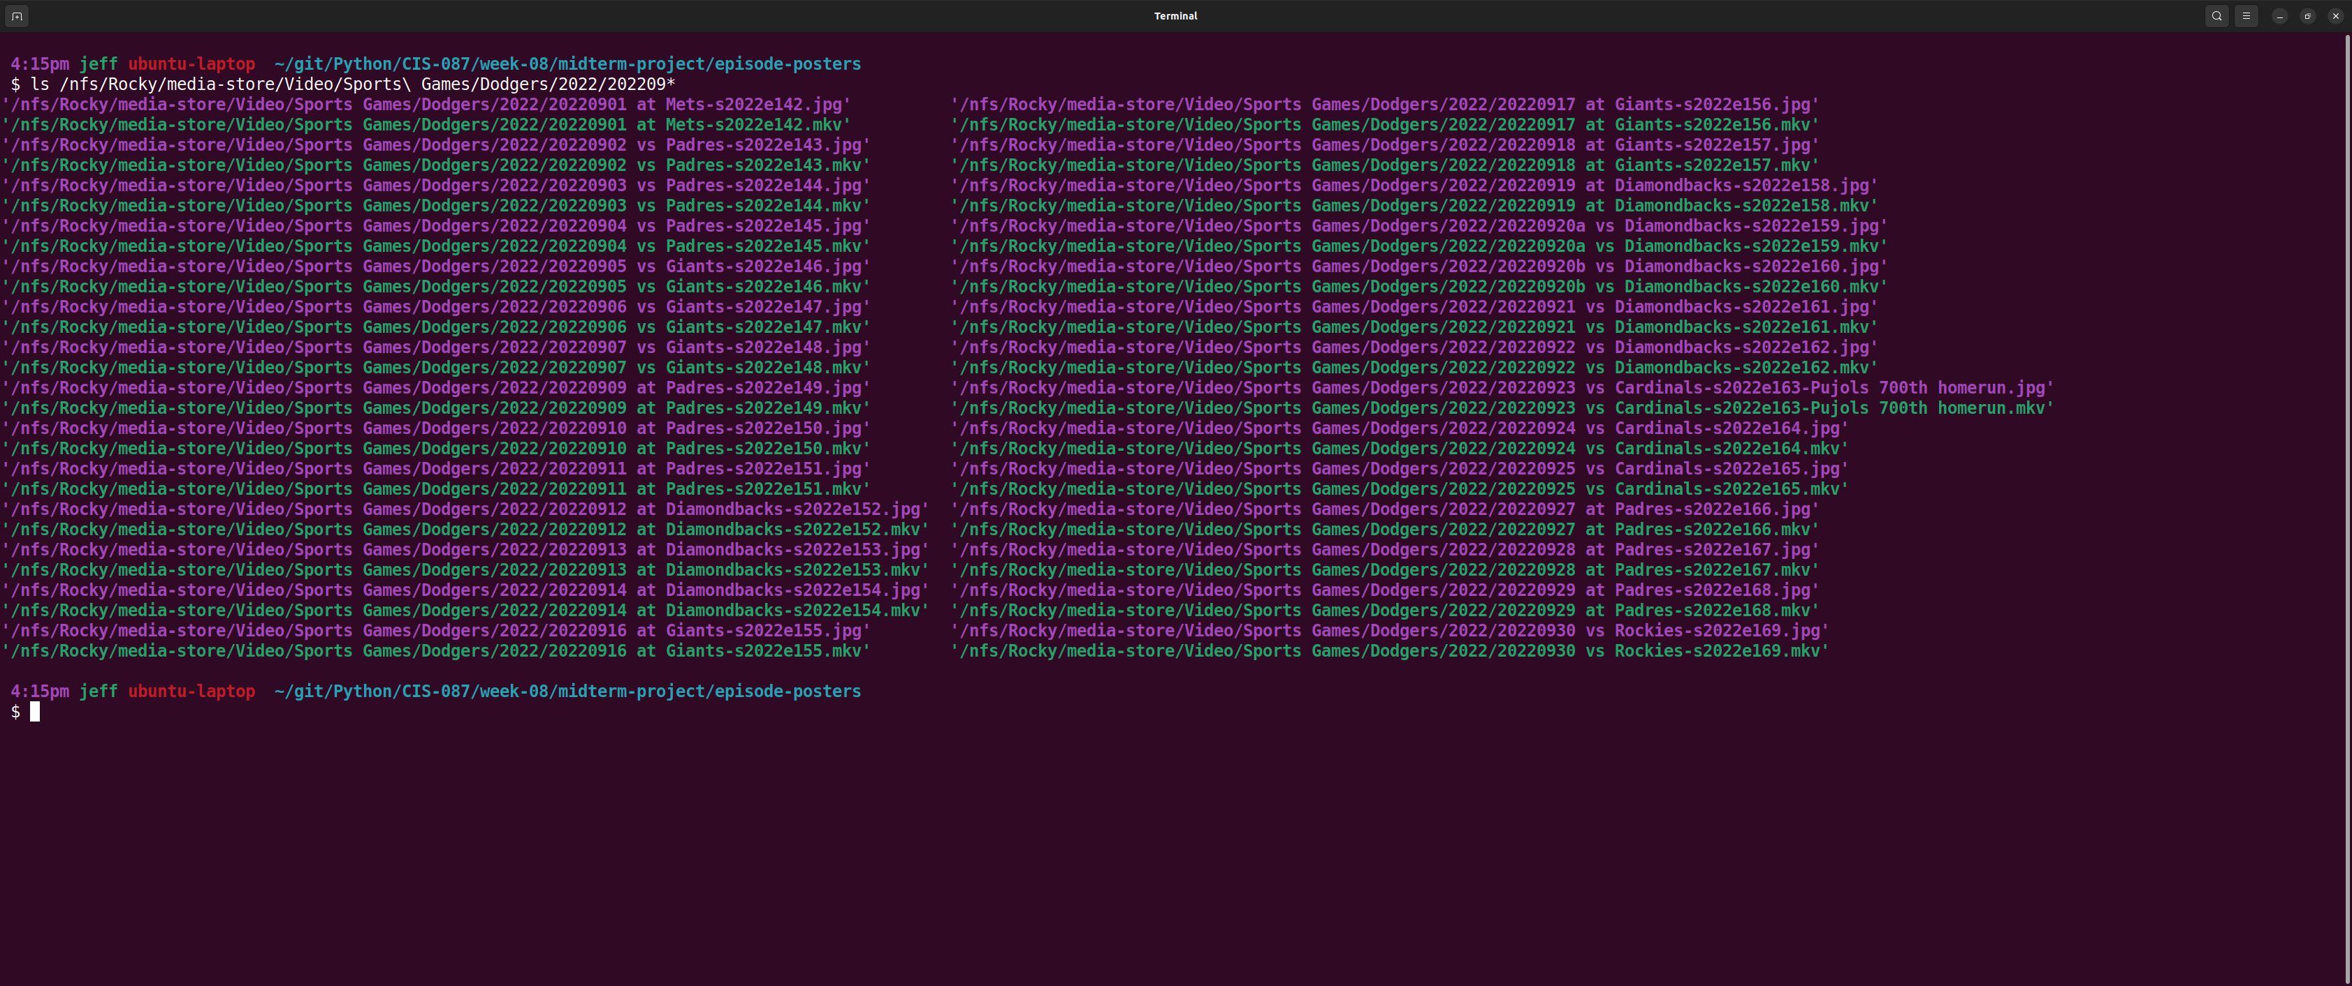

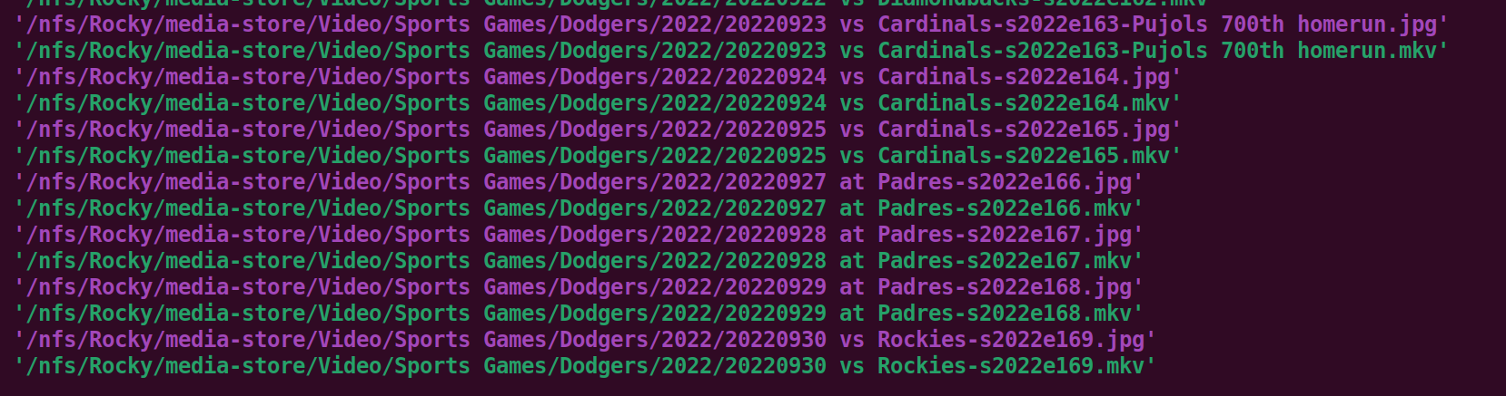Here is the portion of the listing we highlighted in the pre-execution discussion.

Also note that no new files have been created. Each video file in the directory now contains an associated .jpg file as desired.